3. UI\UX

3.1 GUI 1 – HOME

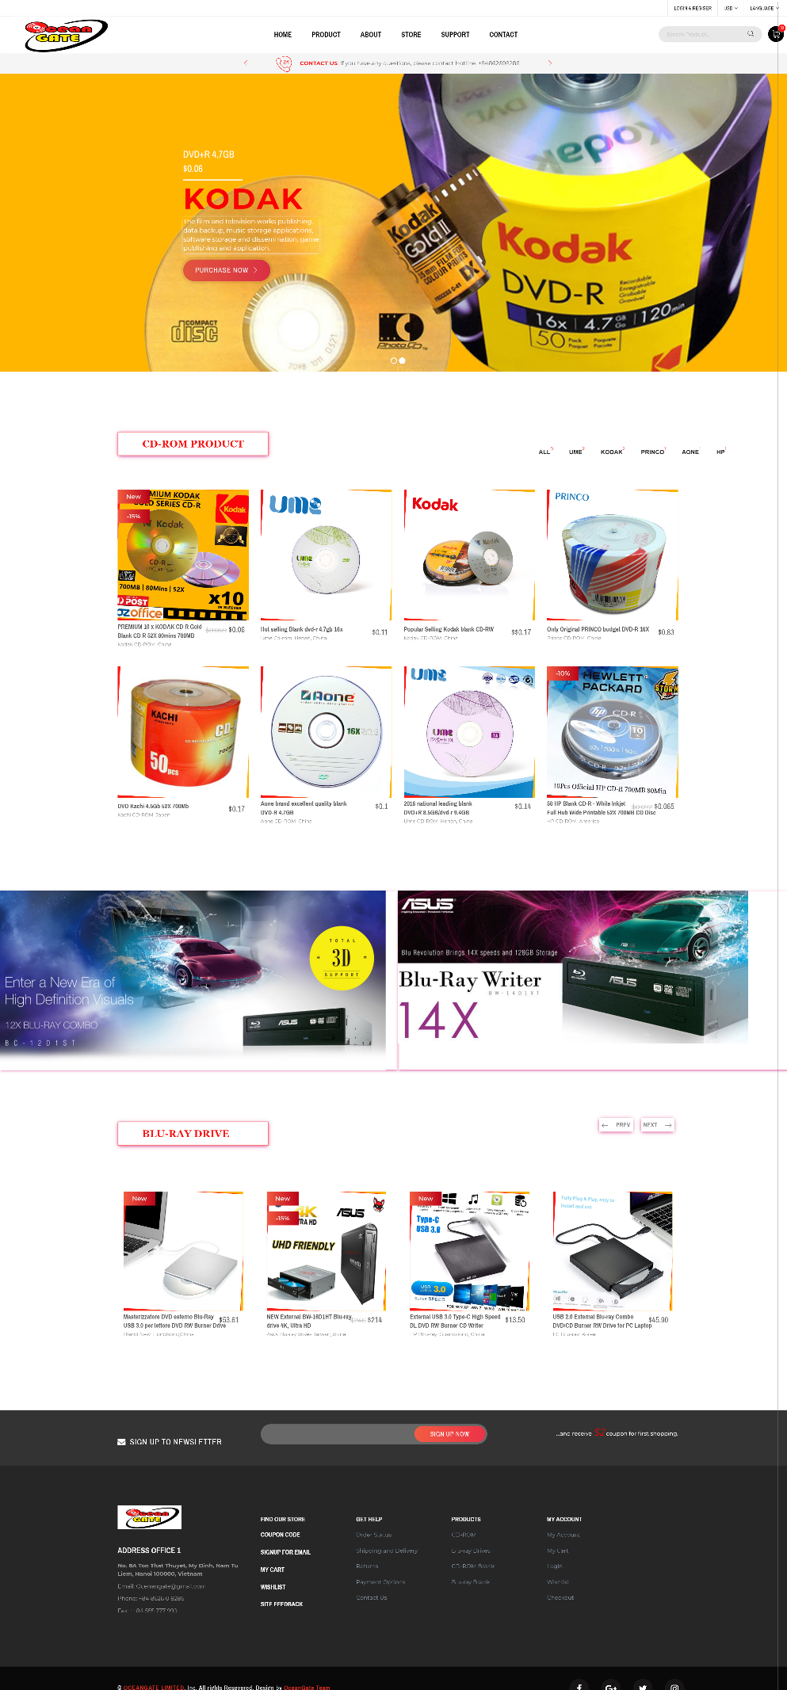

3.2 GUI 2 – PRODUCT

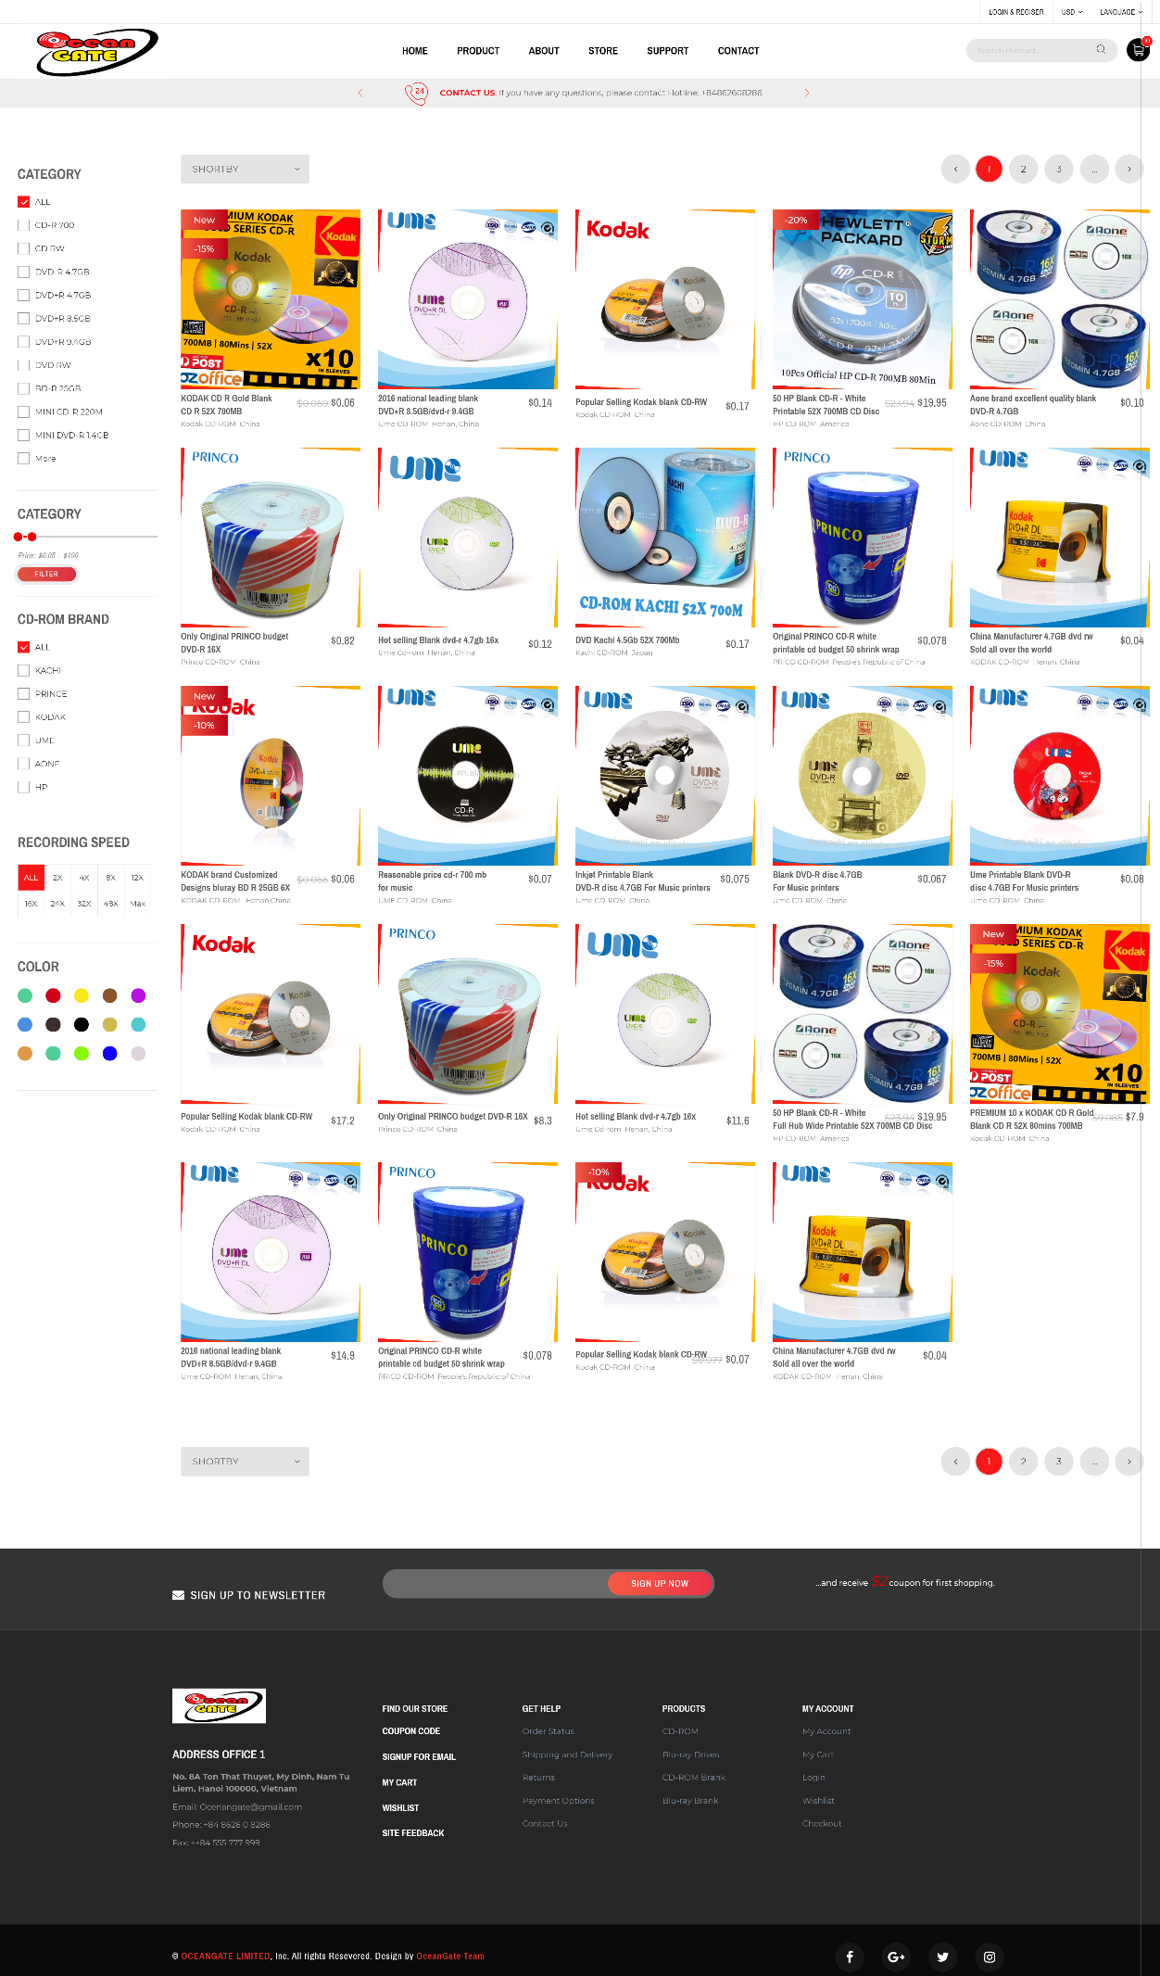

3.3 GUI 3 – ABOUT

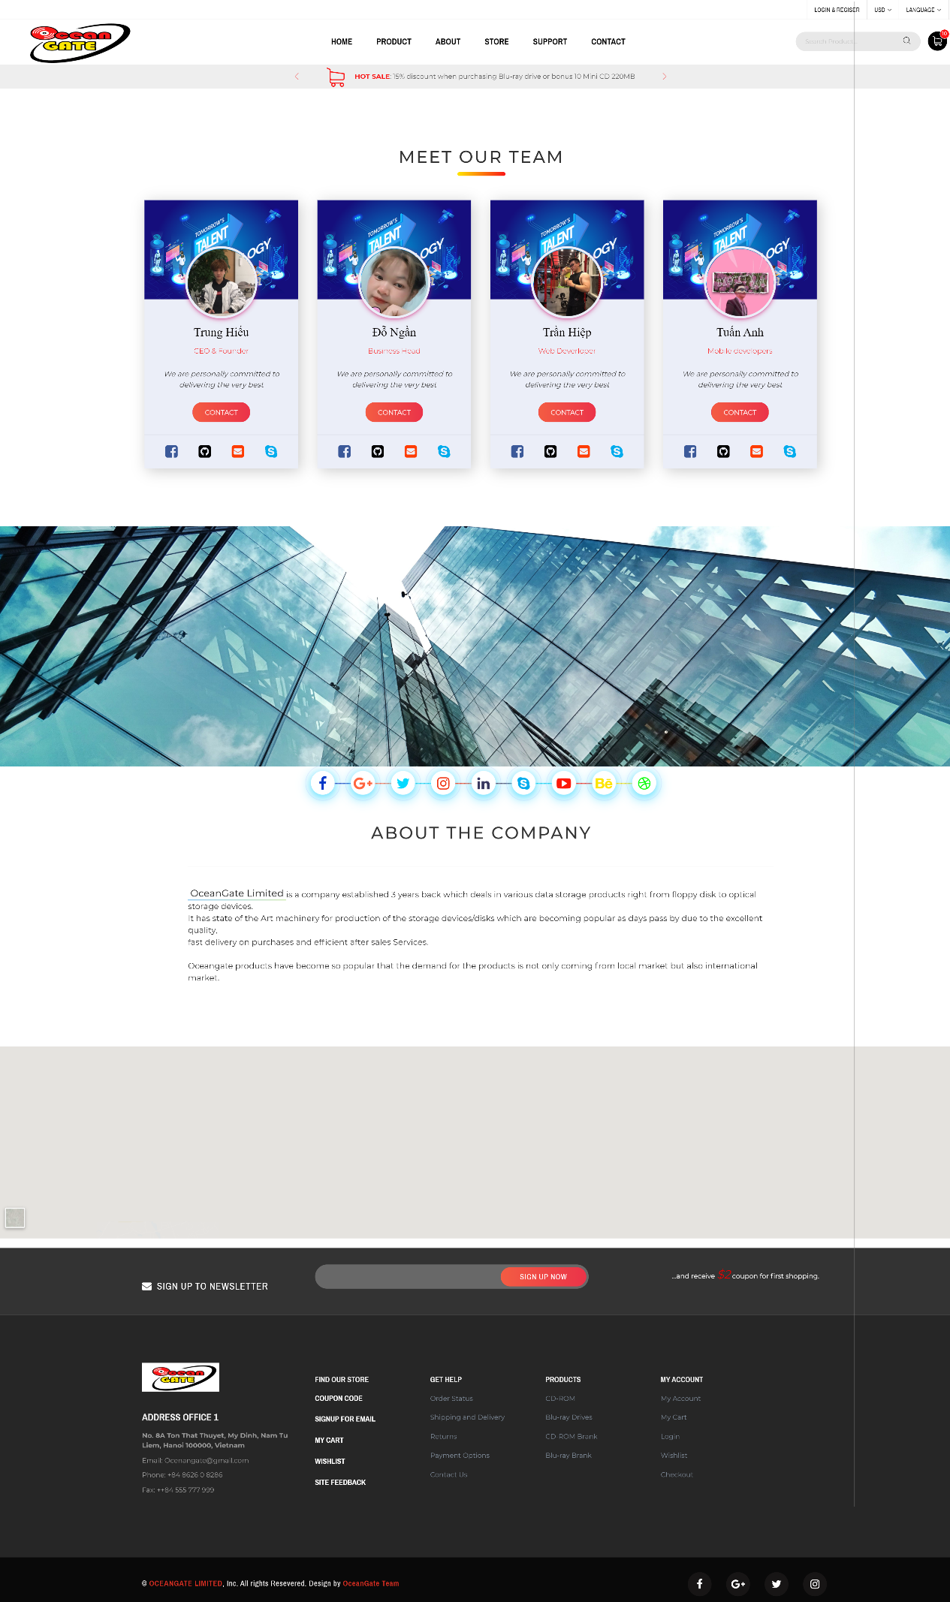

3.4 GUI 4 – STORE

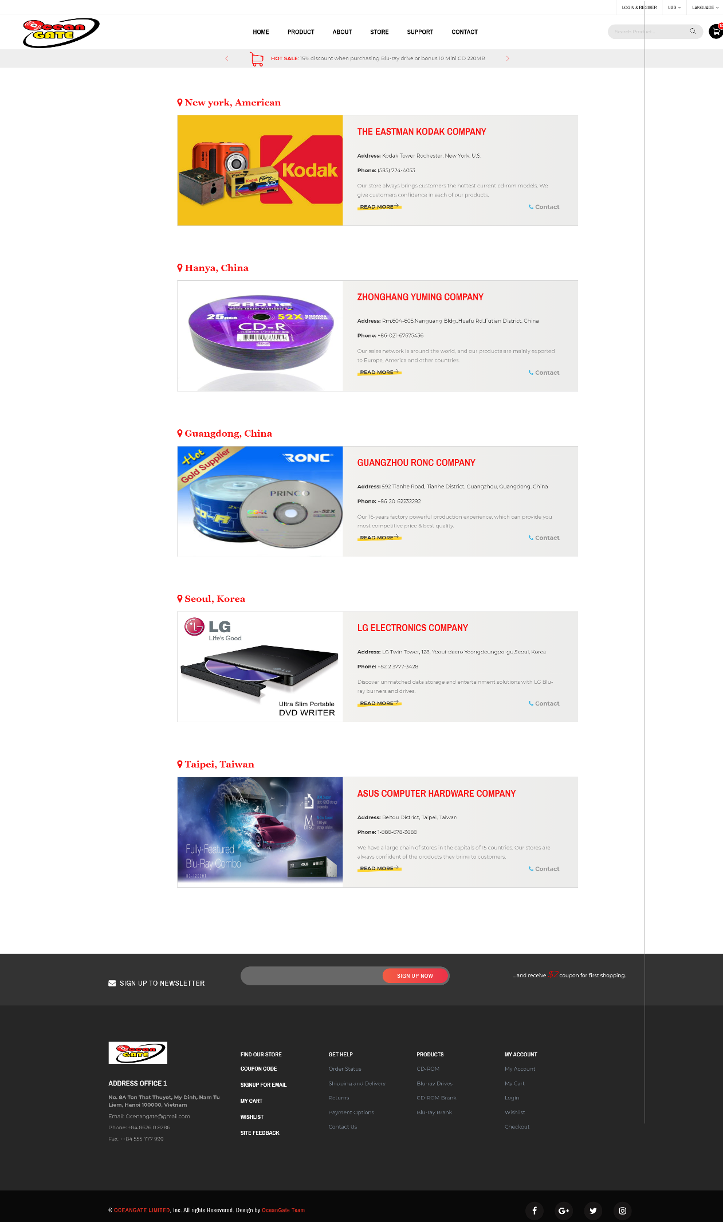

3.5 GUI 5 – SUPPORT

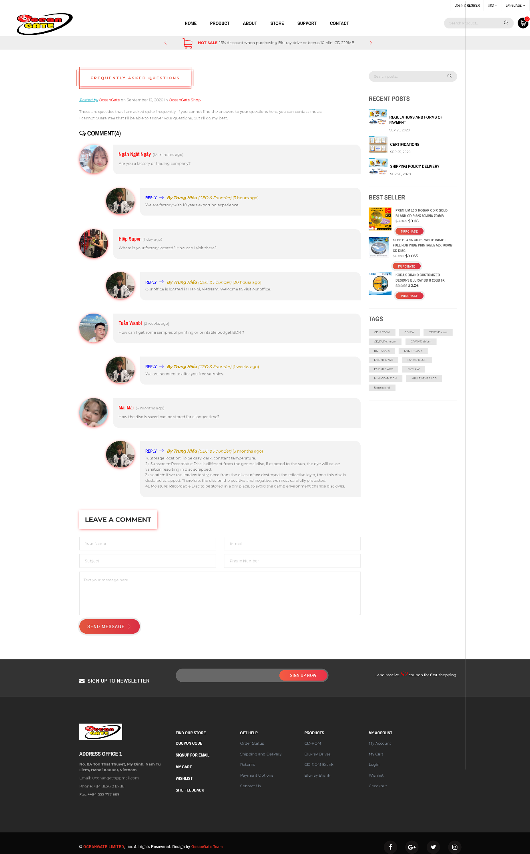

3.6 GUI 6 – CONTACT

